**LED STRIPS 5050-60 6000K/3000K 5 METER ROLL IP20/IP65**

SKU: T654 – 6000k - **IP20 - NON-WATERPROOF**SKU: T655 – 3000k - **IP20 - NON-WATERPROOF**SKU: T656 – 6000k - **IP65 - WATERPROOF**SKU: T657 – 3000k - **IP65 – WATERPROOF**

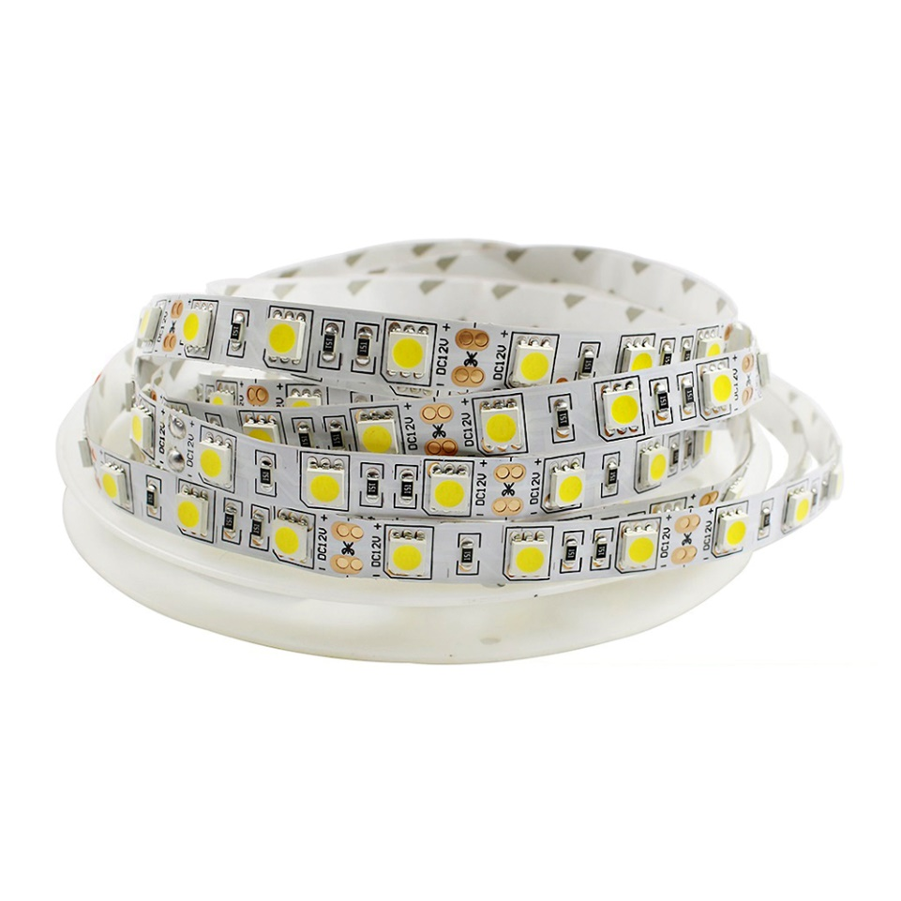

**Description**

The 5m LED Strip 12V DC, SMD5050, 60LED/m, IP20 is one of the most widespread options for decorative or accent lighting with low power consumption. They can be used in any location and add a special touch to any room.

**Features of the LED STRIPS 5050-60 6000K/3000K 5 METER ROLL IP20/IP65**This 12V DC monochrome LED strip is 5 meters long and uses high quality SMD5050 LED technology which emits a total of 1,200lm/m within 120º beam angle.

It has a lifespan of approximately 30,000 hours.

It should be noted that this LED strip is fully dimmable, and with a suitable controller, we can adjust the brightness of light to any preference. Also, note that this strip requires a power supply.

**Advantages of the LED STRIPS 5050-60 6000K/3000K 5 METER ROLL IP20/IP65**With an extremely sleek design, this type of LED lighting can be integrated into any space with a minimalist finish, achieving an ideal lighting effect for all types of projects. Also, the 5m LED Strip 12V DC, SMD5050, 60LED/m, IP20 includes 3M adhesive to facilitate simple installation anywhere you want, from private homes, to more professional applications like commercial or business settings, among many other uses.

Some arrangement ideas for the 5m LED Strip 12V DC, SMD5050, 60LED/m, IP20 would be in different types of rooms or corridors, showcases, shelves, etc... Go to our online LED lighting shop and get the best prices, available in a range of various colours or choose between our cool white, daylight or warm white colour temperatures.

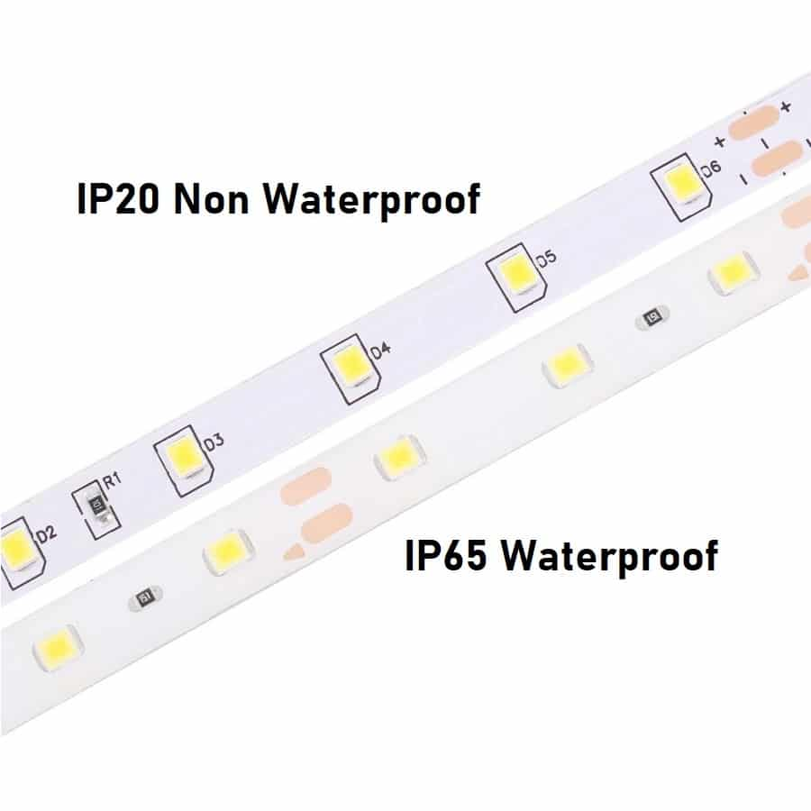

**Power Supplies for 12V DC Strip Lights are sold separately. Please contact us for further information**

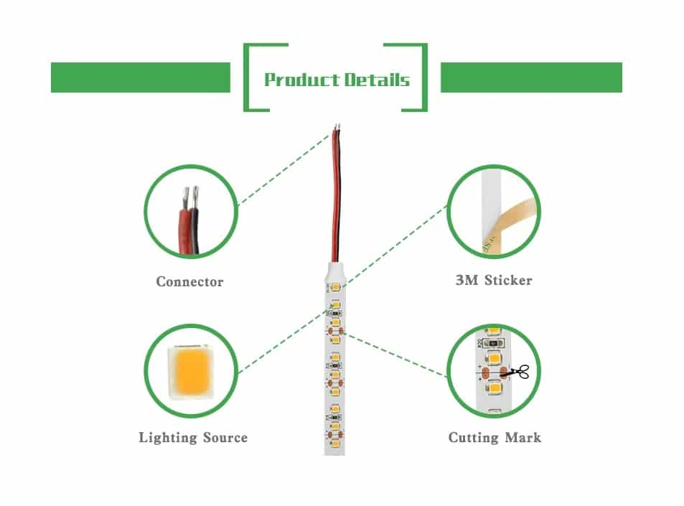

**Specification**

|  |  |
| --- | --- |
| SKU | T654 – 6000k - Non-waterproof  T655 – 3000k -Non-waterproof  T656 – 6000k - Waterproof  T657 – 3000k - Waterproof |
| Power | 14.4W/meter |
| Lumens | 20Lm/SMD Chip |
| Light Source | SMD5050 |
| Number of LEDs | 120 per Meter |
| Cutting Length | 2.5 cm |
| Warranty | 2 Years |
| Certification | CE & ROHS |
| Voltage | 12V DC |
| Beam Angle | 120° Degrees |
| Life Span | 30,000 Hours |
| IP Rating | IP20 or IP65 |
| Dimmable | Yes. With a Dimmable Power Supply |
| Adhesive | 3M |